Task 1

Activity Diagram
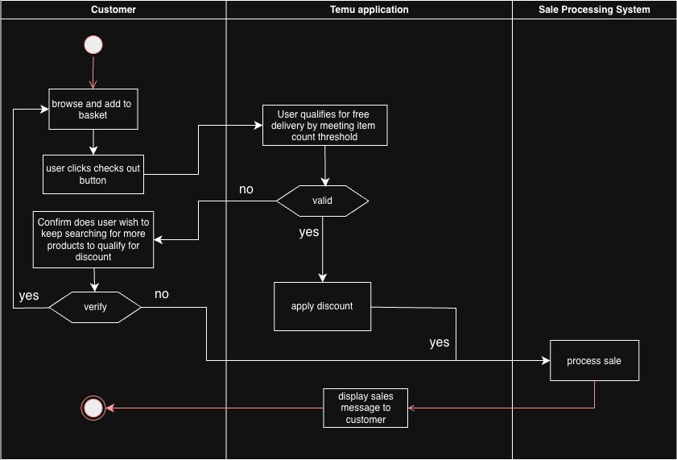

Sequence Diagram
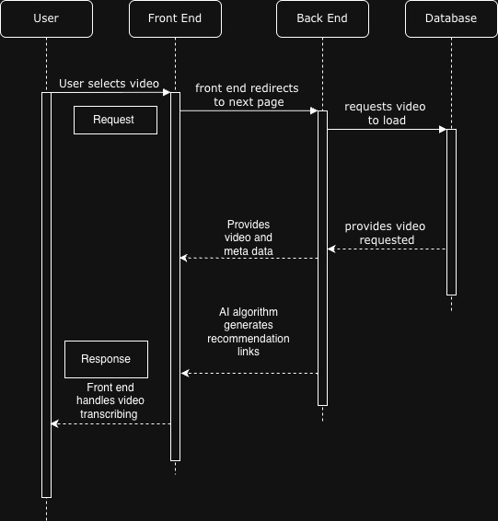

Class Diagram
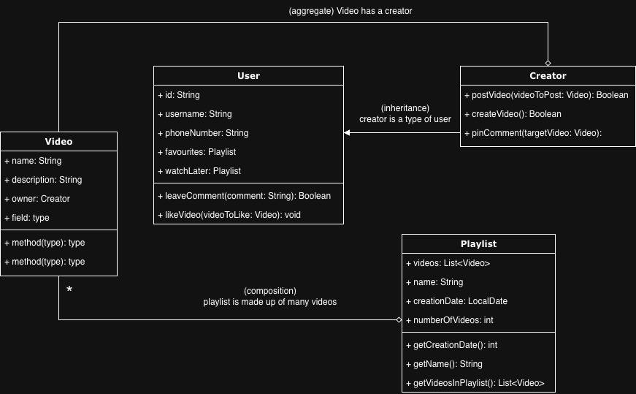

Task 2
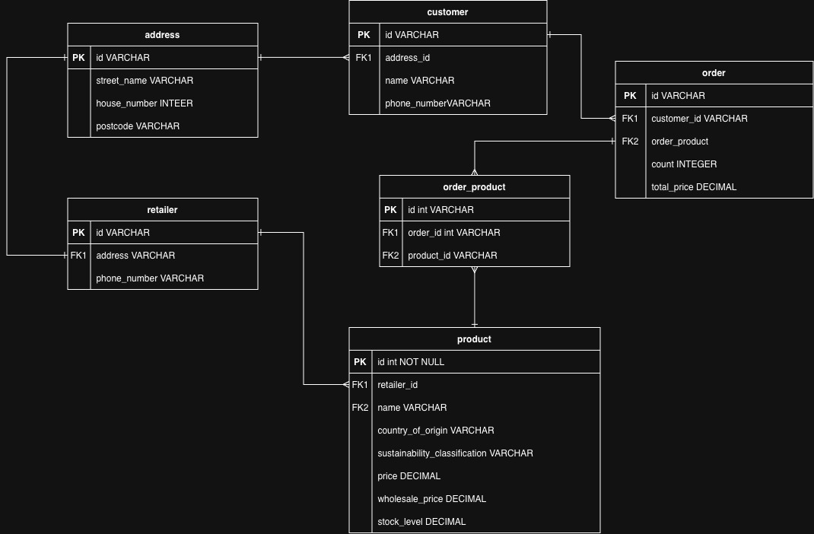
Here is an ERD to depict how entities might relate to each other. I introduced a junction table to handle the many-to-many relationships between products and orders; an order will have many products, and a product will over time belong to many orders. Note that this junction table could also be used for retailer and products, as in theory, many retailers could sell the same products if they both purchase from a given manufacturer. For example, supermarket A and supermarket B might both sell the same brand of cans of cola, but each supermarket will also sell many other products. For the sake of simplicity, I have kept it to a one-to-many relationship. Following this logic, the customer and address entities could also have a many-to-many relationship. It’s also possible that there could be a table for sustainability classification which includes an ID, a description and classification code. My interpretation was that there would be a classification code that is generally accepted in the space of ethically sourced goods, and so just a field in the product column would suffice. In this case it would be good to clarify with the product managers what type of data is required and if an extra entity representing the sustainability classification would be more suitable.

Task 3
Should Northern Green get a lot of traffic to their website, by adopting design and coding option number 2 – reduce data usage - particular retailers that have a lot of visits to their websites could have their information about their products and other read-heavy details stored in a cache when the system makes an API call to the backend. Since stores often have hundreds to thousands of products, this information could be loaded into a cache, especially stores with significant products in the database. Storing the data in a cache will save significant costs when it comes to making calls to the main database and as a result save energy and cost overheads.
Option number 4 – detecting and removing loops – raises a good point regarding maintenance and analysis of the legacy system that will be developed over time. It would be good practice for Northern Green to organise routine checks of the system to ensure that no dead resource endpoints are being hit. Regular re-analysis of the system to remove redundant aspects means that resources will not be spend making calls to the backend that lead to nothing.

